**Install Visual Studio Code**

**Steps to install VS Code in Windows**

**Download the executable file from the link below.**

<https://code.visualstudio.com/>

**Click the option Download**

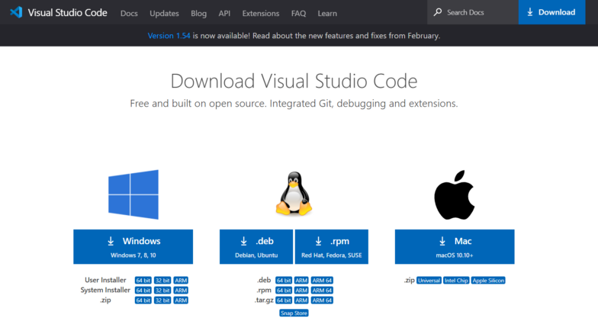

**Double click the downloaded file.**

**Now a dialogue box appears.**

**Select I accept agreement**

**Then select Next**

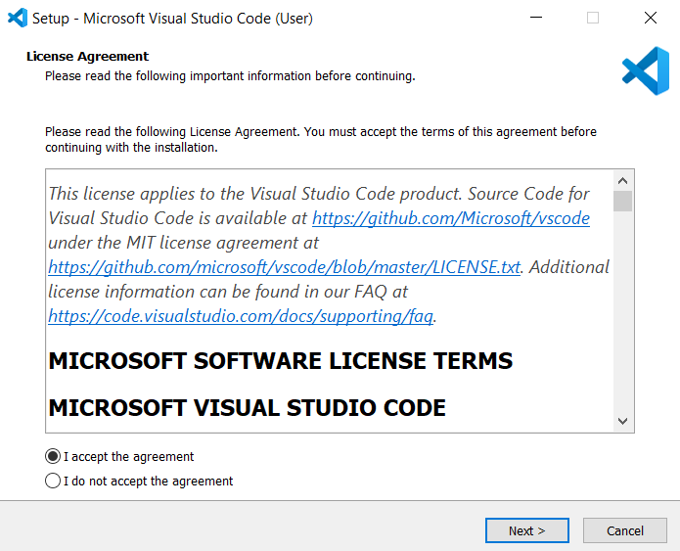

**Select a folder by clicking Browse or just follow the default path.**

**Then select Next.**

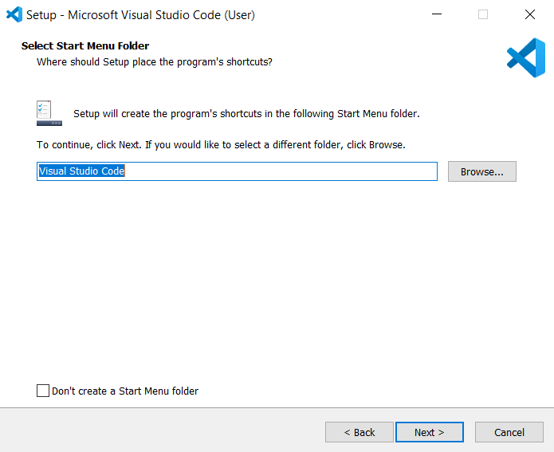

**Select the required options as per your need by clicking in the checkbox.**

**Then select Next.**

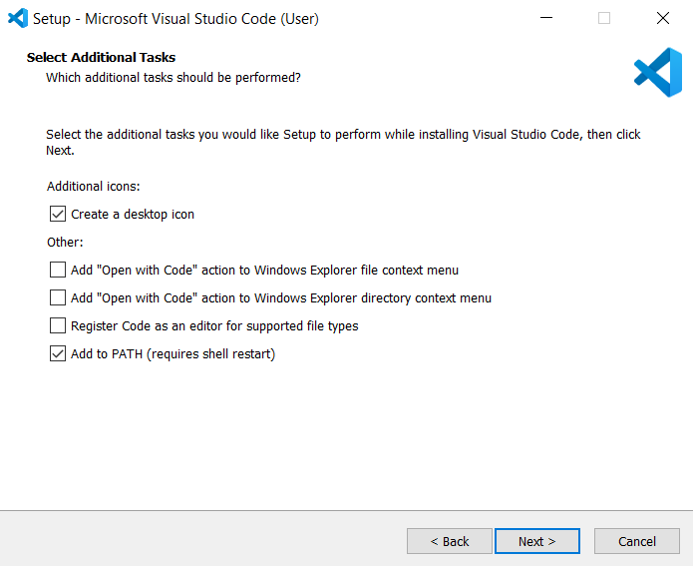

**Select Install.**

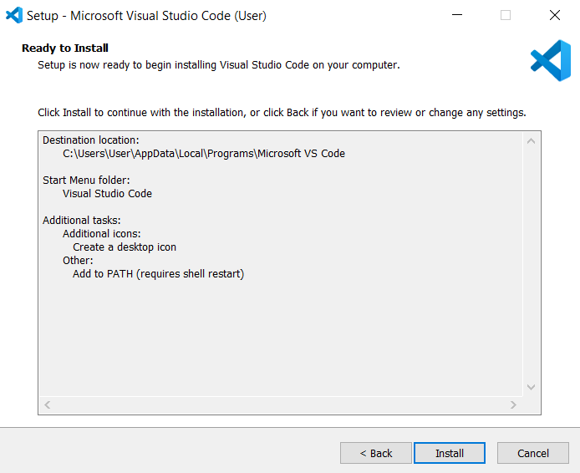

**Wait a bit while it gets installed (The green color fills the bar).**

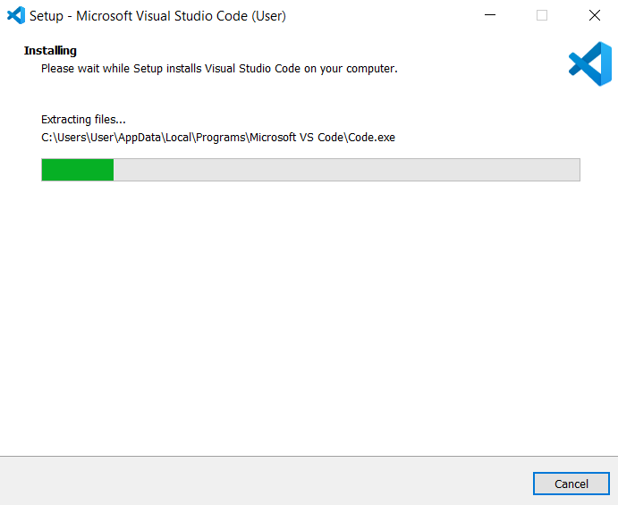

**Click Finish to exit Setup. Check in the check box to launch VS Code right now.**

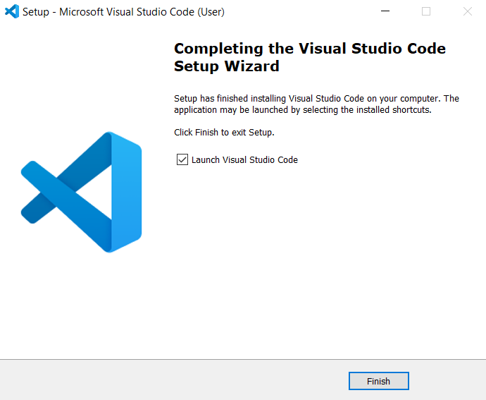

**Congratulation! VS Code got installed in your system successfully.**

**Now a new dialogue box appears. This is VS Code IDE.**

**Click New file to open a new file.**

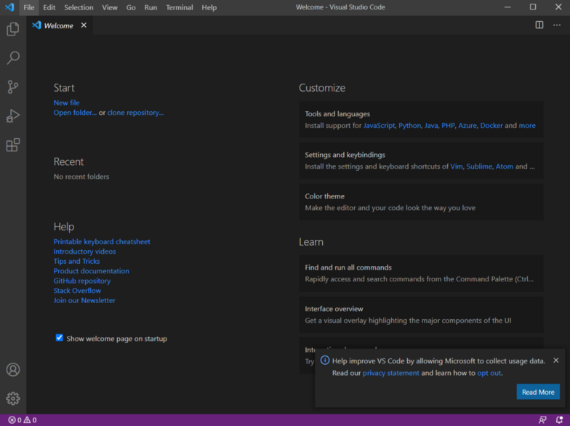

**All done! 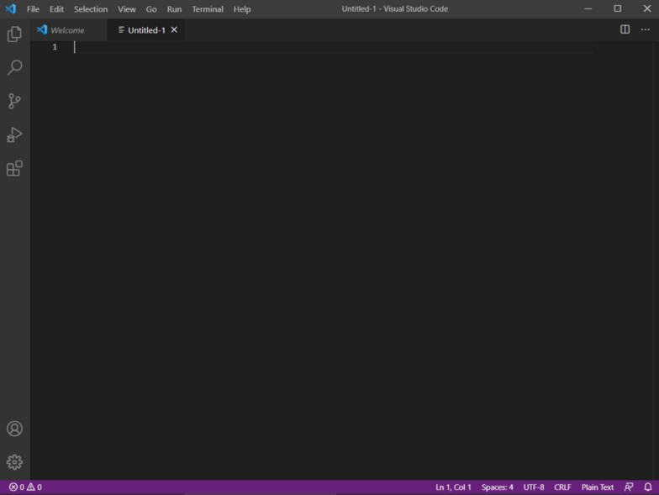Happy Codin**